ASSIGNMENT – III
Subtask 1: Positive, Negative, and Zero.
Code :
import java.awt.EventQueue;
import javax.swing.*;
import javax.swing.border.EmptyBorder;
import java.awt.*;
import java.awt.event.*;

public class positiveNegativeZero extends JFrame {

private static final long serialVersionUID = 1L;
private JPanel contentPane;
private JTextField data;
private JTextArea result; // Declare as field
private JLabel lblNewLabel_2;

public static void main(String[] args) {
EventQueue.invokeLater(new Runnable() {
public void run() {
try {
positiveNegativeZero frame = new positiveNegativeZero();
frame.setVisible(true);
} catch (Exception e) {
e.printStackTrace();
}
}
});
}

public positiveNegativeZero() {
setDefaultCloseOperation(JFrame.EXIT_ON_CLOSE);
setBounds(100, 100, 1002, 612);
contentPane = new JPanel();
contentPane.setBackground(new Color(0, 0, 0));
contentPane.setForeground(new Color(255, 255, 255));
contentPane.setBorder(new EmptyBorder(5, 5, 5, 5));
setContentPane(contentPane);
contentPane.setLayout(null);

JLabel lblNewLabel = new JLabel("Enter a Number : ");
lblNewLabel.setBounds(349, 149, 167, 23);
lblNewLabel.setForeground(new Color(0, 128, 128));
lblNewLabel.setFont(new Font("Times New Roman", Font.BOLD, 21));
contentPane.add(lblNewLabel);

data = new JTextField();
data.setFont(new Font("Times New Roman", Font.BOLD, 18));
data.setBounds(526, 150, 139, 22);
contentPane.add(data);
data.setColumns(10);

JButton btnNewButton = new JButton("CHECK");
btnNewButton.setFont(new Font("Times New Roman", Font.BOLD, 16));
btnNewButton.setBackground(Color.GREEN);
btnNewButton.setBounds(471, 252, 96, 33);
contentPane.add(btnNewButton);

JLabel lblNewLabel_1 = new JLabel("Positive Negative Zero");
lblNewLabel_1.setForeground(Color.WHITE);
lblNewLabel_1.setFont(new Font("Times New Roman", Font.BOLD, 24));
lblNewLabel_1.setBounds(393, 54, 265, 23);
contentPane.add(lblNewLabel_1);
result = new JTextArea();
result.setForeground(new Color(0, 0, 0));
result.setBackground(new Color(112, 128, 144));
result.setFont(new Font("Times New Roman", Font.BOLD, 18));
result.setBounds(358, 368, 333, 112);
result.setEditable(false); // optional, to disable editing user result display
contentPane.add(result);

lblNewLabel_2 = new JLabel("Result :");
lblNewLabel_2.setBackground(new Color(245, 222, 179));
lblNewLabel_2.setForeground(new Color(255, 255, 255));
lblNewLabel_2.setFont(new Font("Times New Roman", Font.BOLD, 20));
lblNewLabel_2.setBounds(358, 332, 96, 26);
contentPane.add(lblNewLabel_2);

btnNewButton.addActionListener(new ActionListener() {
public void actionPerformed(ActionEvent e) {
String input = data.getText().trim();
double num = Double.parseDouble(input);
String displayNum;
if (num == (int) num) {
displayNum = Integer.toString((int) num);
} else {
displayNum = Double.toString(num);
}
if (num > 0) {
result.setText(displayNum + " is a positive number.");
} else if (num < 0) {
result.setText(displayNum + " is a negative number.");
} else {
result.setText(displayNum + " is zero.");
}
}
});
}
}
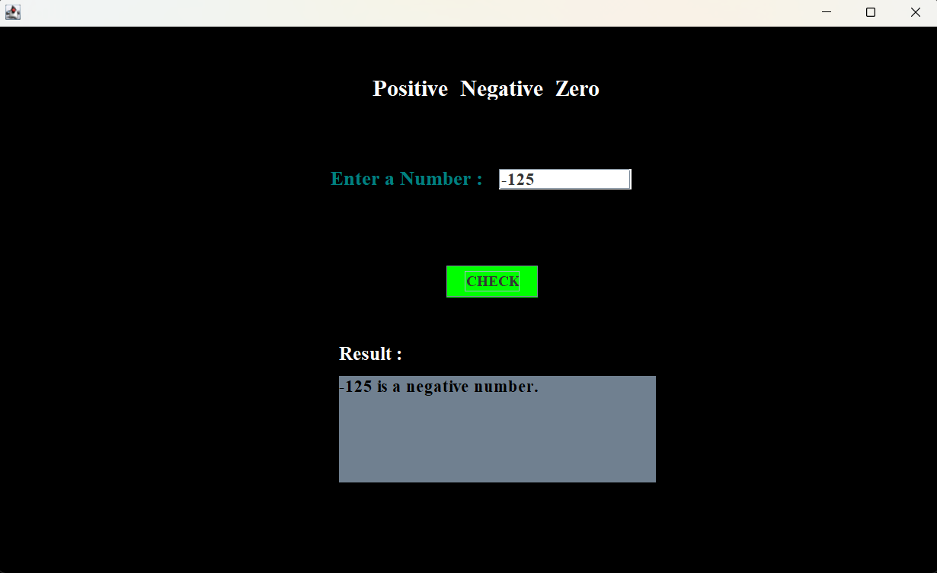
Output :

Subtask 2: Sum of Squares
Code :
import java.awt.EventQueue;
import javax.swing.*;
import javax.swing.border.EmptyBorder;
import java.awt.*;
import java.awt.event.*;
public class sumOfSquares extends JFrame {

private static final long serialVersionUID = 1L;
private JPanel contentPane;
private JTextField data;
private JTextField data2;
private JTextArea result;
private final JLabel lblResult = new JLabel("Result :");

public static void main(String[] args) {
EventQueue.invokeLater(new Runnable() {
public void run() {
try {
sumOfSquares frame = new sumOfSquares();
frame.setVisible(true);
} catch (Exception e) {
e.printStackTrace();
}
}
});
}

public sumOfSquares() {
setDefaultCloseOperation(JFrame.EXIT_ON_CLOSE);
setBounds(100, 100, 1008, 610);
contentPane = new JPanel();
contentPane.setBackground(Color.PINK);
contentPane.setBorder(new EmptyBorder(5, 5, 5, 5));
setContentPane(contentPane);
contentPane.setLayout(null);

JLabel lblNewLabel = new JLabel("Sum Of Squares");
lblNewLabel.setBounds(426, 54, 199, 23);
lblNewLabel.setForeground(new Color(138, 43, 226));
lblNewLabel.setFont(new Font("Times New Roman", Font.BOLD, 24));
contentPane.add(lblNewLabel);

JLabel lblNewLabel_1 = new JLabel("Enter Number 1 : ");
lblNewLabel_1.setFont(new Font("Times New Roman", Font.BOLD, 21));
lblNewLabel_1.setBounds(366, 149, 171, 23);
contentPane.add(lblNewLabel_1);

data = new JTextField();
data.setFont(new Font("Times New Roman", Font.BOLD, 18));
data.setBounds(526, 150, 139, 22);
contentPane.add(data);
data.setColumns(10);

JLabel lblNewLabel_2 = new JLabel("Enter Number 2 :");
lblNewLabel_2.setFont(new Font("Times New Roman", Font.BOLD, 21));
lblNewLabel_2.setBounds(366, 202, 164, 23);
contentPane.add(lblNewLabel_2);

data2 = new JTextField();
data2.setFont(new Font("Times New Roman", Font.BOLD, 18));
data2.setBounds(526, 203, 139, 22);
contentPane.add(data2);
data2.setColumns(10);

result = new JTextArea();
result.setFont(new Font("Times New Roman", Font.BOLD, 18));
result.setBackground(Color.DARK_GRAY);
result.setForeground(Color.WHITE);
result.setBounds(358, 368, 333, 112);
result.setEditable(false);
result.setLineWrap(true);
result.setWrapStyleWord(true);
contentPane.add(result);

JButton btnNewButton = new JButton("CHECK");
btnNewButton.setFont(new Font("Times New Roman", Font.BOLD, 16));
btnNewButton.setBackground(Color.CYAN);
btnNewButton.setBounds(471, 252, 96, 33);
contentPane.add(btnNewButton);
lblResult.setForeground(new Color(148, 0, 211));
lblResult.setBounds(358, 332, 96, 33);
contentPane.add(lblResult);
lblResult.setFont(new Font("Times New Roman", Font.BOLD, 20));

btnNewButton.addActionListener(new ActionListener() {
public void actionPerformed(ActionEvent e) {
String input1 = data.getText().trim();
String input2 = data2.getText().trim();
int num1 = Integer.parseInt(input1);
int num2 = Integer.parseInt(input2);
int start = Math.min(num1, num2);
int end = Math.max(num1, num2);
int sumSquares = 0;
for (int i = start; i <= end; i++) {
sumSquares += i * i;
}
String newOutput = "The Sum of Squares between " + start + " and " + end + " is " + sumSquares + ".";
if (!result.getText().isEmpty()) {
result.append("\n" + newOutput);
} else {
result.setText(newOutput);
}
}
});
}
}
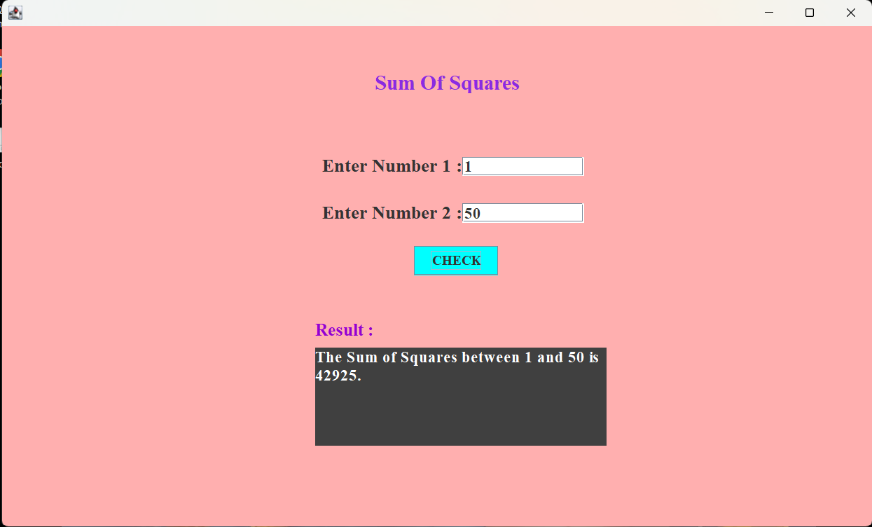
Output :

Subtask 3: Natural Numbers Sum
Code :
import java.awt.EventQueue;
import javax.swing.*;
import javax.swing.border.EmptyBorder;
import java.awt.*;
import java.awt.event.*;

public class naturalNumbersSum extends JFrame {
private static final long serialVersionUID = 1L;
private JPanel contentPane;
private JTextField data;
private JTextArea result; // Declare as field
private JLabel lblNewLabel_2;

public static void main(String[] args) {
EventQueue.invokeLater(new Runnable() {
public void run() {
try {
naturalNumbersSum frame = new naturalNumbersSum();
frame.setVisible(true);
} catch (Exception e) {
e.printStackTrace();
}
}
});
}

public naturalNumbersSum() {
setDefaultCloseOperation(JFrame.EXIT_ON_CLOSE);
setBounds(100, 100, 1002, 610);
contentPane = new JPanel();
contentPane.setBackground(Color.CYAN);
contentPane.setBorder(new EmptyBorder(5, 5, 5, 5));
setContentPane(contentPane);
contentPane.setLayout(null);

JLabel lblNewLabel = new JLabel("Natural Numbers Sum");
lblNewLabel.setForeground(new Color(0, 0, 255));
lblNewLabel.setFont(new Font("Times New Roman", Font.BOLD, 24));
lblNewLabel.setBounds(414, 55, 265, 23);
contentPane.add(lblNewLabel);

JLabel lblNewLabel_1 = new JLabel("Enter Number : ");
lblNewLabel_1.setForeground(Color.BLACK);
lblNewLabel_1.setFont(new Font("Times New Roman", Font.BOLD, 18));
lblNewLabel_1.setBounds(366, 149, 164, 23);
contentPane.add(lblNewLabel_1);

data = new JTextField();
data.setHorizontalAlignment(SwingConstants.LEFT);
data.setFont(new Font("Times New Roman", Font.BOLD, 18));
data.setBounds(526, 150, 139, 22);
contentPane.add(data);
data.setColumns(10);

JButton btnNewButton = new JButton("CHECK");
btnNewButton.setBackground(new Color(34, 139, 34));
btnNewButton.setFont(new Font("Times New Roman", Font.BOLD, 16));
btnNewButton.setBounds(471, 252, 96, 33);
contentPane.add(btnNewButton);

result = new JTextArea();
result.setForeground(Color.WHITE);
result.setFont(new Font("Times New Roman", Font.BOLD, 16));
result.setBackground(Color.GRAY);
result.setBounds(358, 368, 333, 112);
result.setEditable(false);
contentPane.add(result);

lblNewLabel_2 = new JLabel("Result :");
lblNewLabel_2.setForeground(new Color(204, 0, 0));
lblNewLabel_2.setFont(new Font("Times New Roman", Font.BOLD, 20));
lblNewLabel_2.setBounds(358, 332, 96, 26);
contentPane.add(lblNewLabel_2);
btnNewButton.addActionListener(new ActionListener() {
public void actionPerformed(ActionEvent e) {
String input = data.getText().trim();
int num = Integer.parseInt(input);
int sum = num * (num + 1) / 2;
result.setText("The sum of the first " + num + " natural numbers is " + sum + ".");
}
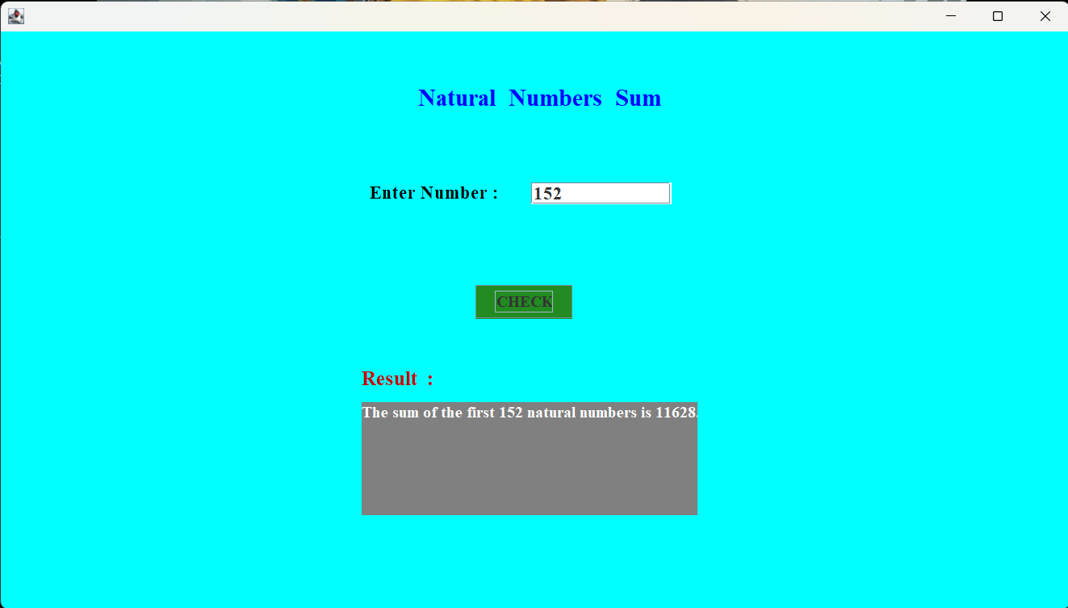
}) }
Output :
Subtask 4: Reverse a Number
Code :
import java.awt.EventQueue;
import javax.swing.*;
import javax.swing.border.EmptyBorder;
import java.awt.*;
import java.awt.event.*;

public class ReverseaNumber extends JFrame {

private static final long serialVersionUID = 1L;
private JPanel contentPane;
private JTextField data;
private JTextArea result; // Declare as field
private JLabel lblNewLabel_2;

public static void main(String[] args) {
EventQueue.invokeLater(new Runnable() {
public void run() {
try {
ReverseaNumber frame = new ReverseaNumber();
frame.setVisible(true);
} catch (Exception e) {
e.printStackTrace();
}
}
});
}

public ReverseaNumber() {
setDefaultCloseOperation(JFrame.EXIT_ON_CLOSE);
setBounds(100, 100, 1002, 609);
contentPane = new JPanel();
contentPane.setBackground(new Color(255, 228, 225));
contentPane.setBorder(new EmptyBorder(5, 5, 5, 5));
setContentPane(contentPane);
contentPane.setLayout(null);

JLabel lblNewLabel = new JLabel("Reverse a Number");
lblNewLabel.setForeground(new Color(0, 100, 0));
lblNewLabel.setBackground(new Color(192, 192, 192));
lblNewLabel.setFont(new Font("Times New Roman", Font.BOLD, 24));
lblNewLabel.setBounds(426, 54, 210, 23);
contentPane.add(lblNewLabel);

JLabel lblNewLabel_1 = new JLabel("Enter a Number :");
lblNewLabel_1.setForeground(new Color(128, 0, 0));
lblNewLabel_1.setFont(new Font("Times New Roman", Font.BOLD, 21));
lblNewLabel_1.setBounds(347, 149, 169, 23);
contentPane.add(lblNewLabel_1);

data = new JTextField();
data.setFont(new Font("Times New Roman", Font.BOLD, 18));
data.setBackground(new Color(240, 248, 255));
data.setBounds(526, 150, 139, 22);
contentPane.add(data);
data.setColumns(10);

result = new JTextArea();
result.setBackground(new Color(135, 206, 235));
result.setFont(new Font("Times New Roman", Font.BOLD, 18));
result.setBounds(358, 368, 333, 112);
result.setEditable(false);
contentPane.add(result);

JButton btnNewButton = new JButton("CHECK");
btnNewButton.setBackground(new Color(124, 252, 0));
btnNewButton.setFont(new Font("Times New Roman", Font.BOLD, 15));
btnNewButton.setBounds(471, 252, 96, 33);
contentPane.add(btnNewButton);

btnNewButton.addActionListener(new ActionListener() {
public void actionPerformed(ActionEvent e) {
String input = data.getText().trim();
int number = Integer.parseInt(input);
int reversed = 0;
int temp = Math.abs(number);

while (temp > 0) {
int digit = temp % 10;
reversed = reversed * 10 + digit;
temp /= 10;
}
if (number < 0) {
reversed = -reversed;
}
result.setText("Reversed Number : " + reversed);

}
});

lblNewLabel_2 = new JLabel("Result :");
lblNewLabel_2.setForeground(new Color(255, 0, 0));
lblNewLabel_2.setFont(new Font("Times New Roman", Font.BOLD, 20));
lblNewLabel_2.setBounds(358, 332, 96, 26);
contentPane.add(lblNewLabel_2);
}
}

Output :
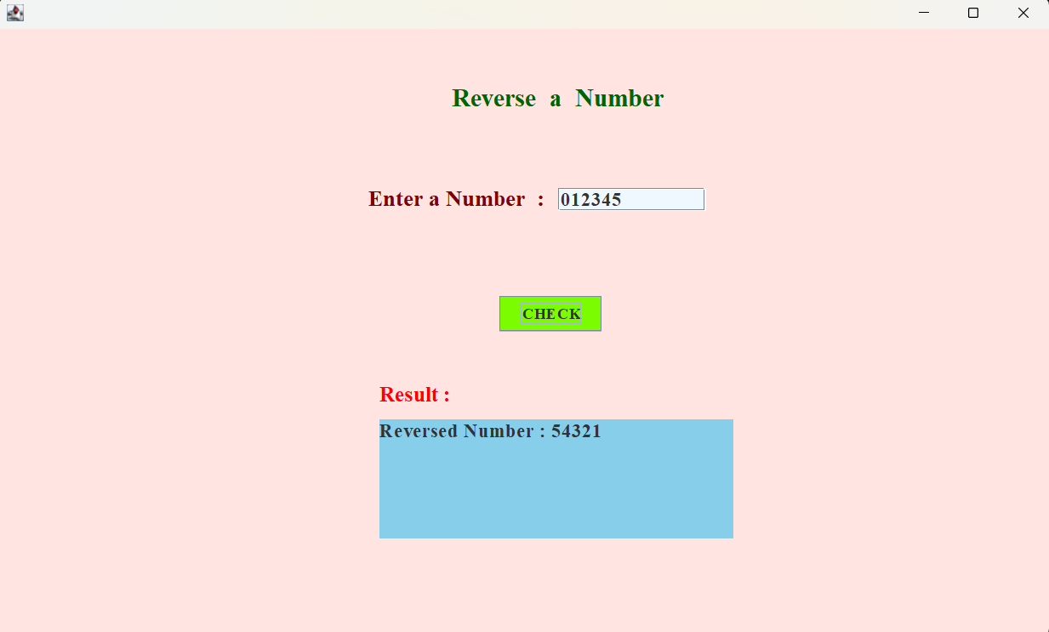
Subtask 5: Prime Numbers
Code :
import java.awt.EventQueue;
import javax.swing.*;
import javax.swing.border.EmptyBorder;
import java.awt.*;
import java.awt.event.*;

public class primeNumber extends JFrame {

private static final long serialVersionUID = 1L;
private JPanel contentPane;
private JTextField data;
private JTextArea result; // Declare as class-level field
private JLabel lblNewLabel_2;

public static void main(String[] args) {
EventQueue.invokeLater(new Runnable() {
public void run() {
try {
primeNumber frame = new primeNumber();
frame.setVisible(true);
} catch (Exception e) {
e.printStackTrace();
}
}
});
}

public primeNumber() {
setDefaultCloseOperation(JFrame.EXIT_ON_CLOSE);
setBounds(100, 100, 1002, 611);
contentPane = new JPanel();
contentPane.setBackground(new Color(255, 250, 205));
contentPane.setBorder(new EmptyBorder(5, 5, 5, 5));
setContentPane(contentPane);
contentPane.setLayout(null);

JLabel lblNewLabel = new JLabel("Check Prime Number or Not");
lblNewLabel.setFont(new Font("Times New Roman", Font.BOLD, 24));
lblNewLabel.setForeground(new Color(255, 0, 255));
lblNewLabel.setBounds(368, 54, 302, 23);
contentPane.add(lblNewLabel);

JLabel lblNewLabel_1 = new JLabel("Enter Number : ");
lblNewLabel_1.setForeground(new Color(139, 69, 19));
lblNewLabel_1.setFont(new Font("Times New Roman", Font.BOLD, 21));
lblNewLabel_1.setBounds(368, 149, 158, 23);
contentPane.add(lblNewLabel_1);
data = new JTextField();
data.setFont(new Font("Times New Roman", Font.BOLD, 18));
data.setBounds(526, 150, 139, 22);
contentPane.add(data);
data.setColumns(10);

JButton btnNewButton = new JButton("CHECK");
btnNewButton.setBackground(new Color(0, 191, 255));
btnNewButton.setForeground(new Color(220, 20, 60));
btnNewButton.setFont(new Font("Times New Roman", Font.BOLD, 15));
btnNewButton.setBounds(471, 252, 96, 33);
contentPane.add(btnNewButton);

result = new JTextArea();
result.setFont(new Font("Times New Roman", Font.BOLD, 18));
result.setBackground(new Color(127, 255, 212));
result.setBounds(358, 368, 333, 112);
result.setEditable(false);
contentPane.add(result);

lblNewLabel_2 = new JLabel("Result :");
lblNewLabel_2.setForeground(new Color(85, 107, 47));
lblNewLabel_2.setFont(new Font("Times New Roman", Font.BOLD, 20));
lblNewLabel_2.setBounds(358, 332, 96, 26);
contentPane.add(lblNewLabel_2);

btnNewButton.addActionListener(new ActionListener() {
public void actionPerformed(ActionEvent e) {
String input = data.getText().trim();
int number = Integer.parseInt(input);
if (number < 2) {
result.setText(number + " is not a prime number.");
return;
}
boolean isPrime = true;
for (int i = 2; i <= Math.sqrt(number); i++) {
if (number % i == 0) {
isPrime = false;
break;
}
}
if (isPrime) {
result.setText(number + " is a prime number.");
} else {
result.setText(number + " is not a prime number.");
}
}
});
}
}
Output :
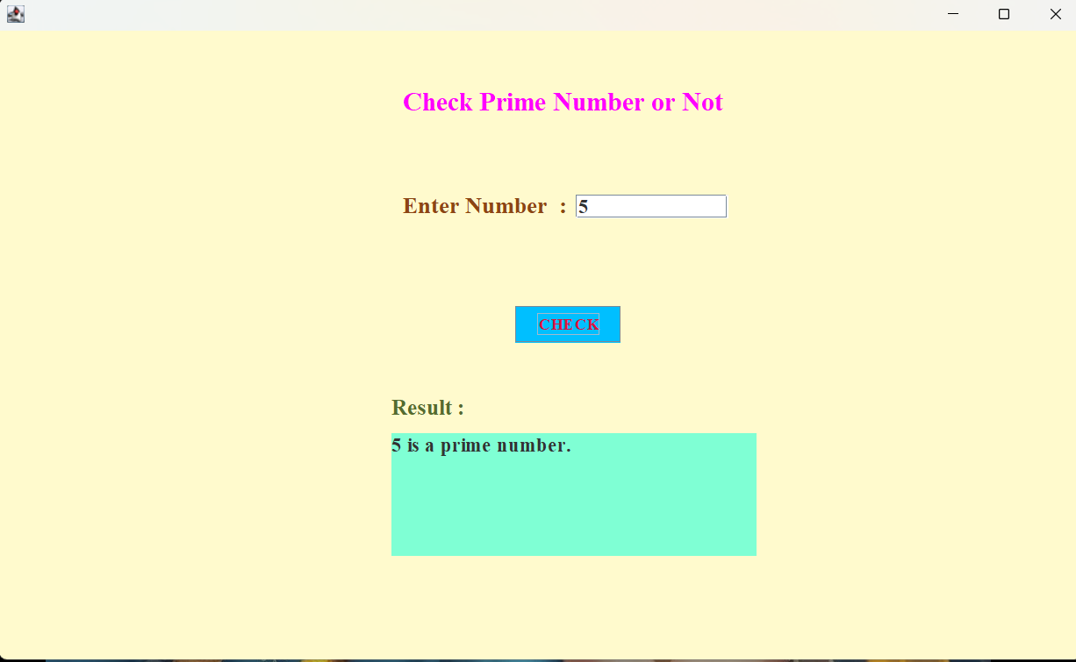

Subtask 6: Prime Number in Range
Code :
import java.awt.EventQueue;
import javax.swing.JFrame;
import javax.swing.JPanel;
import javax.swing.border.EmptyBorder;
import java.awt.Color;
import javax.swing.JLabel;
import java.awt.Font;
import javax.swing.JTextField;
import javax.swing.JTextArea;
import javax.swing.JButton;
import java.awt.event.ActionListener;
import java.awt.event.ActionEvent;

public class primeNumberinRange extends JFrame {

private static final long serialVersionUID = 1L;
private JPanel contentPane;
private JTextField data;
private JTextField data2;

/**
* Launch the application.
*/
public static void main(String[] args) {
EventQueue.invokeLater(new Runnable() {
public void run() {
try {
primeNumberinRange frame = new primeNumberinRange();
frame.setVisible(true);
} catch (Exception e) {
e.printStackTrace();
}
}
});
}

/**
* Create the frame.
*/
public primeNumberinRange() {
setDefaultCloseOperation(JFrame.EXIT_ON_CLOSE);
setBounds(100, 100, 1002, 608);
contentPane = new JPanel();
contentPane.setBackground(new Color(216, 191, 216));
contentPane.setBorder(new EmptyBorder(5, 5, 5, 5));
setContentPane(contentPane);
contentPane.setLayout(null);

JLabel lblNewLabel = new JLabel("Prime Number In Range");
lblNewLabel.setForeground(new Color(30, 144, 255));
lblNewLabel.setFont(new Font("Times New Roman", Font.BOLD, 24));
lblNewLabel.setBounds(416, 49, 264, 33);
contentPane.add(lblNewLabel);

JLabel lblNewLabel_1 = new JLabel("Enter Number 1 :");
lblNewLabel_1.setForeground(new Color(128, 0, 0));
lblNewLabel_1.setFont(new Font("Times New Roman", Font.BOLD, 21));
lblNewLabel_1.setBounds(366, 149, 173, 23);
contentPane.add(lblNewLabel_1);

data = new JTextField();
data.setFont(new Font("Times New Roman", Font.BOLD, 18));
data.setBounds(551, 150, 139, 22);
contentPane.add(data);
data.setColumns(10);

JLabel lblNewLabel_2 = new JLabel("Enter Number 2 :");
lblNewLabel_2.setForeground(new Color(128, 0, 0));
lblNewLabel_2.setFont(new Font("Times New Roman", Font.BOLD, 21));
lblNewLabel_2.setBounds(366, 194, 166, 24);
contentPane.add(lblNewLabel_2);

data2 = new JTextField();
data2.setFont(new Font("Times New Roman", Font.BOLD, 18));
data2.setBounds(551, 195, 139, 22);
contentPane.add(data2);
data2.setColumns(10);

JTextArea result = new JTextArea();
result.setBackground(new Color(176, 224, 230));
result.setFont(new Font("Times New Roman", Font.BOLD, 18));
result.setBounds(358, 368, 333, 141);
contentPane.add(result);

JButton btnNewButton = new JButton("CHECK");
btnNewButton.addActionListener(new ActionListener() {
public void actionPerformed(ActionEvent e) {
String input1 = data.getText().trim();
String input2 = data2.getText().trim();
int num1 = Integer.parseInt(input1);
int num2 = Integer.parseInt(input2);

int start = Math.min(num1, num2);
int end = Math.max(num1, num2);
StringBuilder primes = new StringBuilder();
primes.append("Prime numbers between ").append(start).append(" and ").append(end).append(" are:\n");

boolean foundPrime = false;
for (int i = start; i <= end; i++) {
if (isPrime(i)) {
primes.append(i).append("\n");
foundPrime = true;
}
}
if (!foundPrime) {
primes.append("No prime numbers found in this range.");
}
result.setText(primes.toString());
}
private boolean isPrime(int n) {
if (n < 2) return false;
for (int i = 2; i <= Math.sqrt(n); i++) {
if (n % i == 0) return false;
}
return true;
}
});
btnNewButton.setBackground(new Color(0, 255, 0));
btnNewButton.setForeground(new Color(106, 90, 205));
btnNewButton.setFont(new Font("Times New Roman", Font.BOLD, 16));
btnNewButton.setBounds(471, 252, 96, 33);
contentPane.add(btnNewButton);

JLabel lblNewLabel_3 = new JLabel("Result :");
lblNewLabel_3.setFont(new Font("Times New Roman", Font.BOLD, 20));
lblNewLabel_3.setForeground(new Color(0, 0, 255));
lblNewLabel_3.setBackground(new Color(221, 160, 221));
lblNewLabel_3.setBounds(358, 332, 96, 26);
contentPane.add(lblNewLabel_3);

}
}

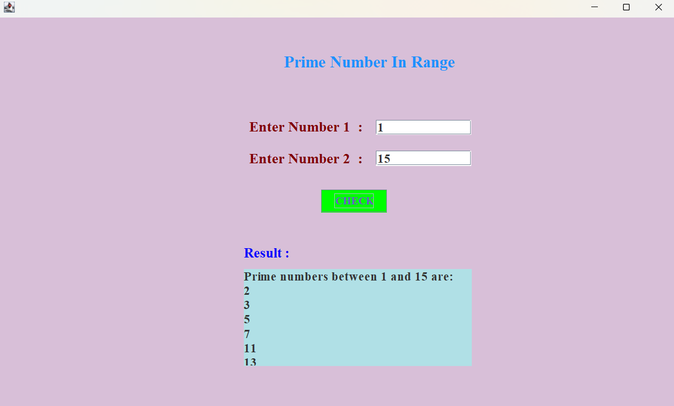
Output :

Subtask 7: Caluclate Factorial
Code :
import java.awt.EventQueue;
import javax.swing.*;
import javax.swing.border.EmptyBorder;
import java.awt.*;
import java.awt.event.*;

public class caluclateFactorial extends JFrame {
private static final long serialVersionUID = 1L;
private JPanel contentPane;
private JTextField data;
private JTextArea result;
public static void main(String[] args)
EventQueue.invokeLater(() -> {
try {
caluclateFactorial frame = new caluclateFactorial();
frame.setVisible(true);
} catch (Exception e) {
e.printStackTrace();
}
});
}

public caluclateFactorial() {
setDefaultCloseOperation(JFrame.EXIT_ON_CLOSE);
setBounds(100, 100, 1002, 610);
contentPane = new JPanel();
contentPane.setBackground(new Color(144, 238, 144));
contentPane.setBorder(new EmptyBorder(5, 5, 5, 5));
setContentPane(contentPane);
contentPane.setLayout(null);

JLabel lblNewLabel = new JLabel("Find Factorial");
lblNewLabel.setForeground(new Color(255, 0, 0));
lblNewLabel.setFont(new Font("Times New Roman", Font.BOLD, 24));
lblNewLabel.setBounds(445, 55, 199, 23);
contentPane.add(lblNewLabel);

JLabel lblNewLabel_1 = new JLabel("Enter Number : ");
lblNewLabel_1.setForeground(new Color(153, 50, 204));
lblNewLabel_1.setFont(new Font("Times New Roman", Font.BOLD, 21));
lblNewLabel_1.setBounds(366, 149, 164, 23);
contentPane.add(lblNewLabel_1);

data = new JTextField();
data.setFont(new Font("Times New Roman", Font.BOLD, 18));
data.setBounds(526, 150, 139, 22);
contentPane.add(data);
data.setColumns(10);

JButton btnNewButton = new JButton("CHECK");
btnNewButton.setBackground(new Color(0, 153, 204));
btnNewButton.setFont(new Font("Times New Roman", Font.BOLD, 16));
btnNewButton.setBounds(461, 253, 96, 33);
contentPane.add(btnNewButton);

btnNewButton.addActionListener(new ActionListener() {
public void actionPerformed(ActionEvent e) {
String input = data.getText().trim();
int number = Integer.parseInt(input);
long factorial = 1;
for (int i = 1; i <= number; i++) {
factorial *= i;
}
result.setText("Factorial of " + number + " is : " + factorial);
}
});

result = new JTextArea();
result.setForeground(new Color(0, 0, 0));
result.setFont(new Font("Times New Roman", Font.BOLD, 18));
result.setBackground(new Color(245, 222, 179));
result.setBounds(358, 368, 333, 112);
result.setEditable(false);
contentPane.add(result);

JLabel lblNewLabel_2 = new JLabel("Result :");
lblNewLabel_2.setForeground(Color.DARK_GRAY);
lblNewLabel_2.setFont(new Font("Times New Roman", Font.BOLD, 20));
lblNewLabel_2.setBounds(358, 332, 96, 26);
contentPane.add(lblNewLabel_2);
}
}
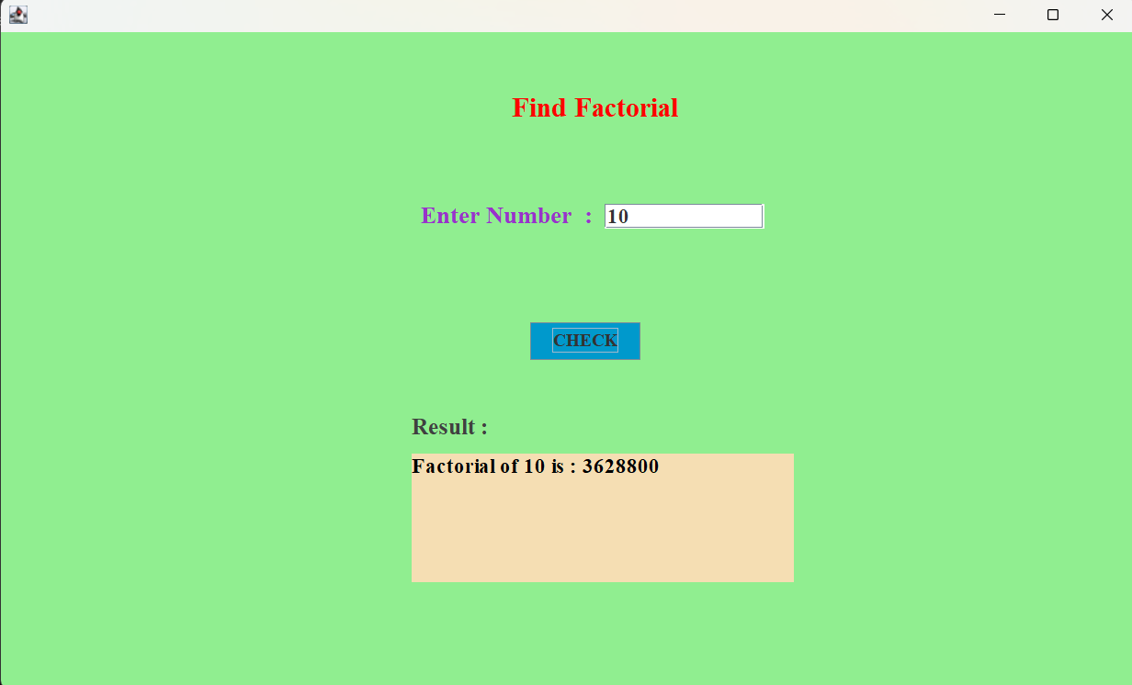
Output :

Subtask 8: Nth Term Series
Code :
import java.awt.EventQueue;
import javax.swing.*;
import javax.swing.border.EmptyBorder;
import java.awt.*;
import java.awt.event.*;

public class nthTermofSeries extends JFrame {

private static final long serialVersionUID = 1L;
private JPanel contentPane;
private JTextField data;
private JTextArea result; // Class-level declaration
private JLabel lblNewLabel_2;

public static void main(String[] args) {
EventQueue.invokeLater(() -> {
try {
nthTermofSeries frame = new nthTermofSeries();
frame.setVisible(true);
} catch (Exception e) {
e.printStackTrace();
}
});
}

public nthTermofSeries() {
setDefaultCloseOperation(JFrame.EXIT_ON_CLOSE);
setBounds(100, 100, 1002, 610);
contentPane = new JPanel();
contentPane.setBackground(new Color(255, 228, 196));
contentPane.setBorder(new EmptyBorder(5, 5, 5, 5));
setContentPane(contentPane);
contentPane.setLayout(null);

JLabel lblNewLabel = new JLabel("Nth Term Of Series");
lblNewLabel.setForeground(new Color(139, 0, 139));
lblNewLabel.setFont(new Font("Times New Roman", Font.BOLD, 24));
lblNewLabel.setBounds(417, 55, 224, 23);
contentPane.add(lblNewLabel);

JLabel lblNewLabel_1 = new JLabel("Enter Number : ");
lblNewLabel_1.setForeground(new Color(139, 0, 0));
lblNewLabel_1.setFont(new Font("Times New Roman", Font.BOLD, 21));
lblNewLabel_1.setBounds(366, 149, 164, 23);
contentPane.add(lblNewLabel_1);

data = new JTextField();
data.setFont(new Font("Times New Roman", Font.BOLD, 18));
data.setBounds(526, 150, 139, 22);
contentPane.add(data);
data.setColumns(10);

JButton btnNewButton = new JButton("CHECK");
btnNewButton.setFont(new Font("Times New Roman", Font.BOLD, 13));
btnNewButton.setForeground(new Color(255, 0, 0));
btnNewButton.setBackground(Color.CYAN);
btnNewButton.setBounds(471, 252, 96, 33);
contentPane.add(btnNewButton);

btnNewButton.addActionListener(new ActionListener() {
public void actionPerformed(ActionEvent e) {
String input = data.getText().trim();
int n = Integer.parseInt(input);
int nthTerm = n * (n + 1) / 2;
result.setText("The number " + n + " th term of series is " + nthTerm + ".");
}
});

result = new JTextArea();
result.setFont(new Font("Times New Roman", Font.BOLD, 18));
result.setBounds(358, 368, 333, 112);
result.setEditable(false);
contentPane.add(result);

lblNewLabel_2 = new JLabel("Result :");
lblNewLabel_2.setForeground(Color.BLUE);
lblNewLabel_2.setFont(new Font("Times New Roman", Font.BOLD, 20));
lblNewLabel_2.setBounds(358, 332, 96, 26);
contentPane.add(lblNewLabel_2);
}
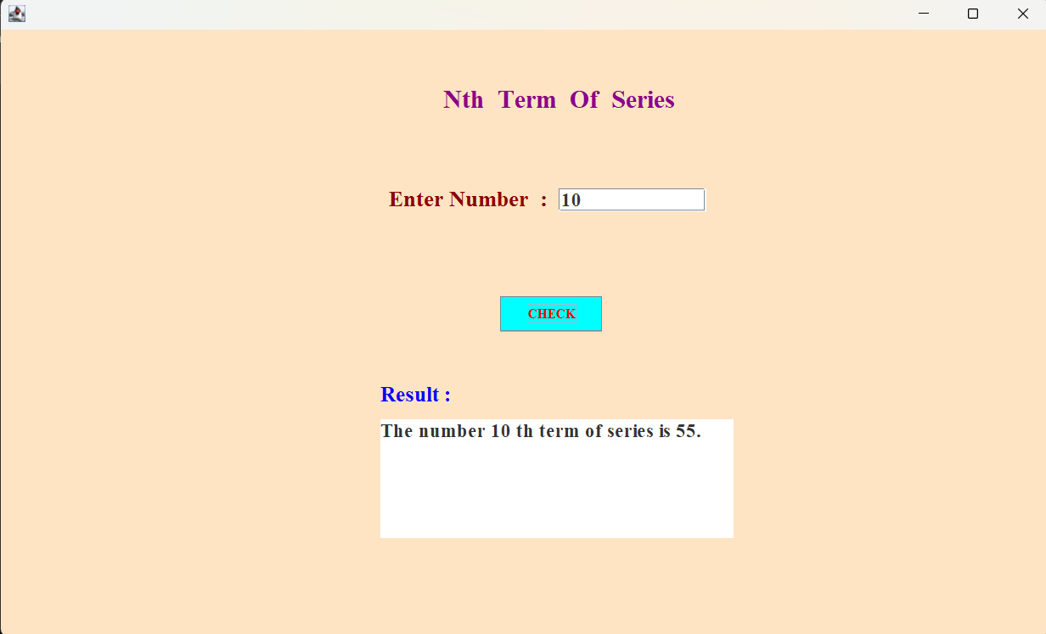
} Output :
Subtask 9: N Number of Fibonacci Series
Code :
import java.awt.EventQueue;
import javax.swing.JFrame;
import javax.swing.JPanel;
import javax.swing.border.EmptyBorder;
import javax.swing.JLabel;
import java.awt.Font;
import java.awt.Color;
import javax.swing.JTextField;
import javax.swing.JButton;
import javax.swing.JTextArea;
import java.awt.event.ActionListener;
import java.awt.event.ActionEvent;

public class fibonacciSeries extends JFrame {

JPanel contentPane;
JTextField data;
JTextArea result;
private JLabel lblNewLabel_2;

public static void main(String[] args) {
EventQueue.invokeLater(new Runnable() {
public void run() {
try {
fibonacciSeries frame = new fibonacciSeries();
frame.setVisible(true);
} catch (Exception e) {
e.printStackTrace();
}
}
});
}

public fibonacciSeries() {
setDefaultCloseOperation(JFrame.EXIT_ON_CLOSE);
setBounds(100, 100, 1014, 615);
contentPane = new JPanel();
contentPane.setBackground(Color.DARK_GRAY);
contentPane.setBorder(new EmptyBorder(5, 5, 5, 5));
setContentPane(contentPane);
contentPane.setLayout(null);

JLabel lblNewLabel = new JLabel("Fibonacci Series");
lblNewLabel.setForeground(new Color(0, 255, 0));
lblNewLabel.setFont(new Font("Times New Roman", Font.BOLD, 24));
lblNewLabel.setBounds(426, 54, 199, 23);
contentPane.add(lblNewLabel);

JLabel lblNewLabel_1 = new JLabel("Enter Number :");
lblNewLabel_1.setFont(new Font("Times New Roman", Font.BOLD, 21));
lblNewLabel_1.setForeground(new Color(0, 191, 255));
lblNewLabel_1.setBounds(366, 149, 164, 23);
contentPane.add(lblNewLabel_1);

data = new JTextField();
data.setFont(new Font("Times New Roman", Font.BOLD, 18));
data.setBounds(526, 150, 139, 22);
contentPane.add(data);
data.setColumns(10);

JButton btnNewButton = new JButton("CHECK");
btnNewButton.addActionListener(new ActionListener() {
public void actionPerformed(ActionEvent e) {
String input = data.getText().trim();
int n = Integer.parseInt(input);
StringBuilder fibSeries = new StringBuilder();
int a = 0, b = 1;
for (int i = 0; i < n; i++) {
fibSeries.append(a);
if (i != n - 1) {
fibSeries.append(" ");
}
int next = a + b;
a = b;
b = next;
}
result.setText("Fibonacci series up to " + n + " : " + fibSeries.toString());
}
});

btnNewButton.setBackground(new Color(0, 255, 255));
btnNewButton.setForeground(new Color(0, 0, 0));
btnNewButton.setFont(new Font("Times New Roman", Font.BOLD, 16));
btnNewButton.setBounds(471, 252, 96, 33);
contentPane.add(btnNewButton);

result = new JTextArea();
result.setFont(new Font("Times New Roman", Font.BOLD, 18));
result.setBounds(334, 368, 380, 112);
contentPane.add(result);

lblNewLabel_2 = new JLabel("Result :");
lblNewLabel_2.setForeground(new Color(51, 255, 51));
lblNewLabel_2.setFont(new Font("Times New Roman", Font.BOLD, 20));
lblNewLabel_2.setBounds(358, 332, 96, 26);
contentPane.add(lblNewLabel_2);
}
}
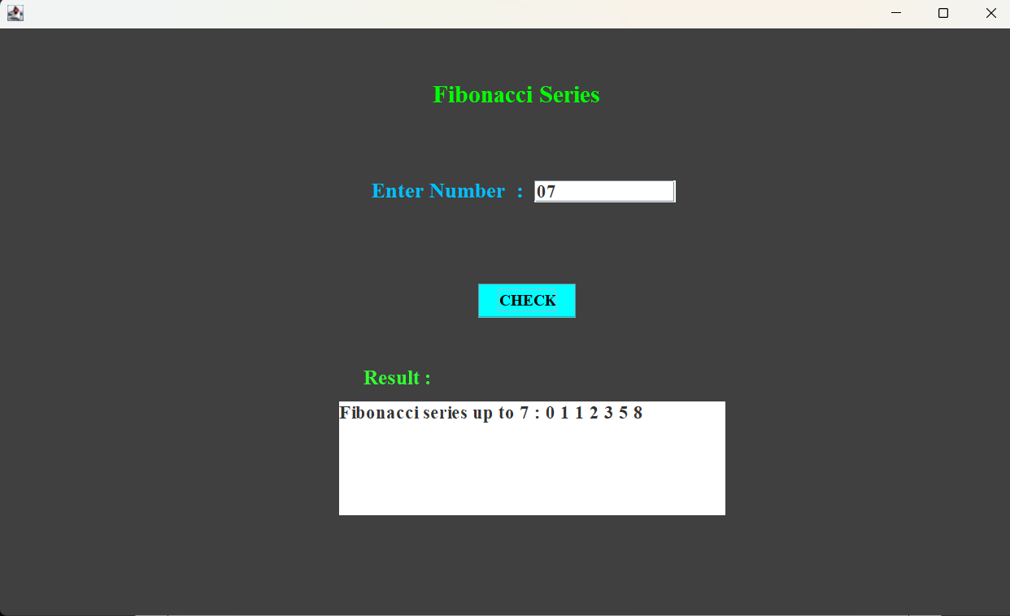
Output :

Subtask 10: Odd Sum
Code :
import java.awt.EventQueue;
import javax.swing.JFrame;
import javax.swing.JPanel;
import javax.swing.border.EmptyBorder;
import java.awt.Color;
import javax.swing.JLabel;
import java.awt.Font;
import javax.swing.JTextField;
import javax.swing.JButton;
import javax.swing.JTextArea;
import java.awt.event.ActionListener;
import java.awt.event.ActionEvent;

public class oddSum extends JFrame {

private JPanel contentPane;
private JTextField data;
private JTextField data2;
private JTextArea result;
private JLabel lblNewLabel_3;

public static void main(String[] args) {
EventQueue.invokeLater(new Runnable() {
public void run() {
try {
oddSum frame = new oddSum();
frame.setVisible(true);
} catch (Exception e) {
e.printStackTrace();
}
}
});
}

public oddSum() {
setDefaultCloseOperation(JFrame.EXIT_ON_CLOSE);
setBounds(100, 100, 1002, 610);
contentPane = new JPanel();
contentPane.setBackground(new Color(102, 205, 170));
contentPane.setBorder(new EmptyBorder(5, 5, 5, 5));
setContentPane(contentPane);
contentPane.setLayout(null);

JLabel lblNewLabel = new JLabel("Odd Sum Numbers");
lblNewLabel.setForeground(new Color(0, 0, 0));
lblNewLabel.setFont(new Font("Times New Roman", Font.BOLD, 24));
lblNewLabel.setBounds(426, 54, 214, 23);
contentPane.add(lblNewLabel);

JLabel lblNewLabel_1 = new JLabel("Enter Number 1 :");
lblNewLabel_1.setForeground(new Color(0, 0, 255));
lblNewLabel_1.setFont(new Font("Times New Roman", Font.BOLD, 18));
lblNewLabel_1.setBounds(366, 149, 164, 23);
contentPane.add(lblNewLabel_1);

data = new JTextField();
data.setFont(new Font("Times New Roman", Font.BOLD, 18));
data.setBounds(526, 150, 139, 22);
contentPane.add(data);
data.setColumns(10);

JLabel lblNewLabel_2 = new JLabel("Enter Number 2 :");
lblNewLabel_2.setForeground(new Color(0, 0, 139));
lblNewLabel_2.setFont(new Font("Times New Roman", Font.BOLD, 18));
lblNewLabel_2.setBounds(366, 199, 164, 23);
contentPane.add(lblNewLabel_2);

data2 = new JTextField();
data2.setFont(new Font("Times New Roman", Font.BOLD, 18));
data2.setBounds(526, 201, 139, 22);
contentPane.add(data2);
data2.setColumns(10);

JButton btnNewButton = new JButton("CHECK");
btnNewButton.setBackground(new Color(255, 165, 0));
btnNewButton.setFont(new Font("Times New Roman", Font.BOLD, 15));
btnNewButton.setBounds(471, 252, 96, 33);
contentPane.add(btnNewButton);

btnNewButton.addActionListener(new ActionListener() {
public void actionPerformed(ActionEvent e) {
String input1 = data.getText().trim();
String input2 = data2.getText().trim();
int num1 = Integer.parseInt(input1);
int num2 = Integer.parseInt(input2);
if (num1 > num2) {
int temp = num1;
num1 = num2;
num2 = temp;
}
int sumOdd = 0;
for (int i = num1; i <= num2; i++) {
if (i % 2 != 0) {
sumOdd += i;
}
}
result.setText("The sum of all odd numbers between " + num1 + " and " + num2 + " is " + sumOdd);
}
});

result = new JTextArea();
result.setBackground(new Color(192, 192, 192));
result.setFont(new Font("Times New Roman", Font.BOLD, 18));
result.setBounds(358, 368, 333, 112);
result.setLineWrap(true); // Enable line wrap
result.setWrapStyleWord(true); // Wrap at word boundaries
contentPane.add(result);

lblNewLabel_3 = new JLabel("Result :");
lblNewLabel_3.setForeground(new Color(138, 43, 226));
lblNewLabel_3.setFont(new Font("Times New Roman", Font.BOLD, 20));
lblNewLabel_3.setBounds(358, 332, 96, 26);
contentPane.add(lblNewLabel_3);
}
}
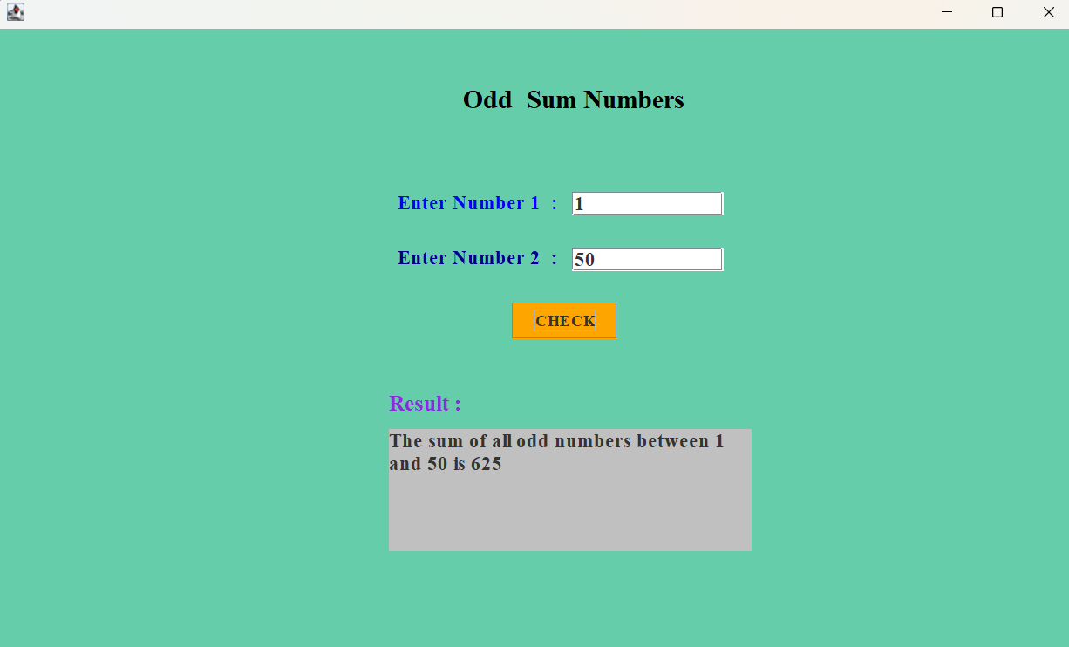
Output :

Subtask 11: Sum of Digits Integer
Code :
import java.awt.EventQueue;
import javax.swing.JFrame;
import javax.swing.JPanel;
import javax.swing.border.EmptyBorder;
import java.awt.Color;
import javax.swing.JLabel;
import java.awt.Font;
import javax.swing.JTextField;
import javax.swing.JButton;
import javax.swing.JTextArea;
import java.awt.event.ActionListener;
import java.awt.event.ActionEvent;

public class sumOfDigits extends JFrame {

private JPanel contentPane;
private JTextField data;
private JTextArea result;
private JLabel lblNewLabel_2;

public static void main(String[] args) {
EventQueue.invokeLater(new Runnable() {
public void run() {
try {
sumOfDigits frame = new sumOfDigits();
frame.setVisible(true);
} catch (Exception e) {
e.printStackTrace();
}
}
});
}

public sumOfDigits() {
setDefaultCloseOperation(JFrame.EXIT_ON_CLOSE);
setBounds(100, 100, 1002, 611);
contentPane = new JPanel();
contentPane.setBackground(new Color(0, 250, 154));
contentPane.setBorder(new EmptyBorder(5, 5, 5, 5));
setContentPane(contentPane);
contentPane.setLayout(null);

JLabel lblNewLabel = new JLabel("Sum Of Digits");
lblNewLabel.setFont(new Font("Times New Roman", Font.BOLD, 24));
lblNewLabel.setBounds(443, 51, 199, 33);
contentPane.add(lblNewLabel);

JLabel lblNewLabel_1 = new JLabel("Enter Number :");
lblNewLabel_1.setForeground(new Color(25, 25, 112));
lblNewLabel_1.setFont(new Font("Times New Roman", Font.BOLD, 21));
lblNewLabel_1.setBounds(366, 149, 164, 23);
contentPane.add(lblNewLabel_1);

data = new JTextField();
data.setFont(new Font("Times New Roman", Font.BOLD, 18));
data.setBounds(526, 150, 139, 22);
contentPane.add(data);
data.setColumns(10);

JButton btnNewButton = new JButton("CHECK");
btnNewButton.setBackground(new Color(106, 90, 205));
btnNewButton.setFont(new Font("Times New Roman", Font.BOLD, 16));
btnNewButton.setBounds(471, 252, 96, 33);
contentPane.add(btnNewButton);

btnNewButton.addActionListener(new ActionListener() {
public void actionPerformed(ActionEvent e) {
String input = data.getText().trim();
int number = Integer.parseInt(input);
int sum = 0;
int temp = Math.abs(number);

while (temp > 0) {
sum += temp % 10;
temp /= 10;
}
String newText = "Sum of digits : " + sum;
if (!result.getText().isEmpty()) {
newText = result.getText() + "\n" + newText;
}
result.setText(newText);
}
});

result = new JTextArea();
result.setBackground(new Color(220, 220, 220));
result.setFont(new Font("Times New Roman", Font.BOLD, 18));
result.setBounds(358, 368, 333, 112);
result.setLineWrap(true);
result.setWrapStyleWord(true);
contentPane.add(result);

lblNewLabel_2 = new JLabel("Result :");
lblNewLabel_2.setForeground(new Color(0, 0, 128));
lblNewLabel_2.setFont(new Font("Times New Roman", Font.BOLD, 20));
lblNewLabel_2.setBounds(358, 332, 96, 26);
contentPane.add(lblNewLabel_2);
}
}
Output :
